

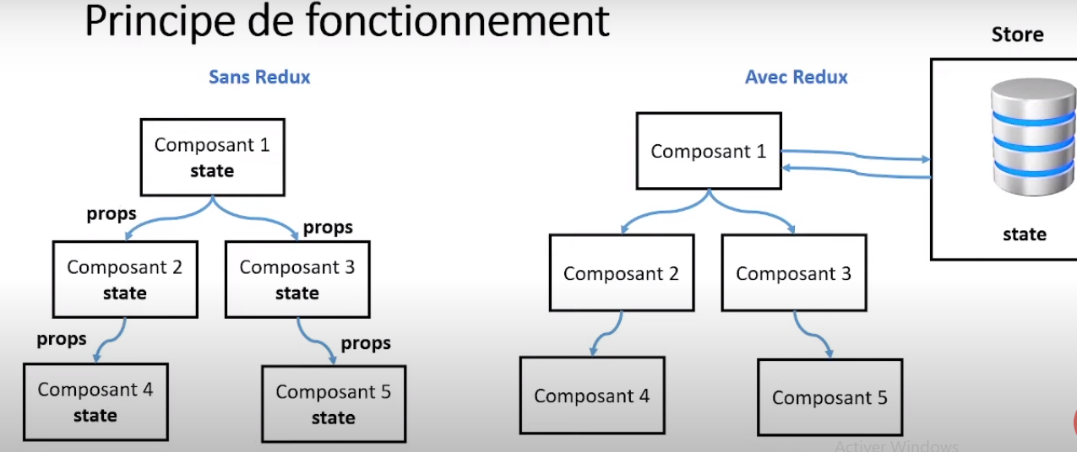

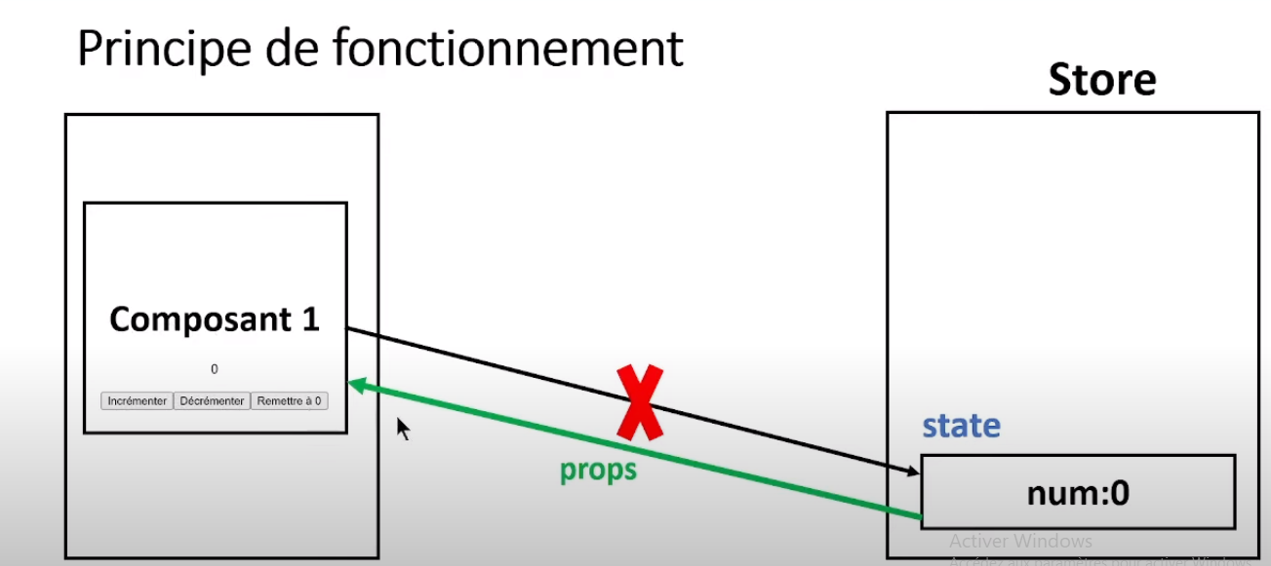

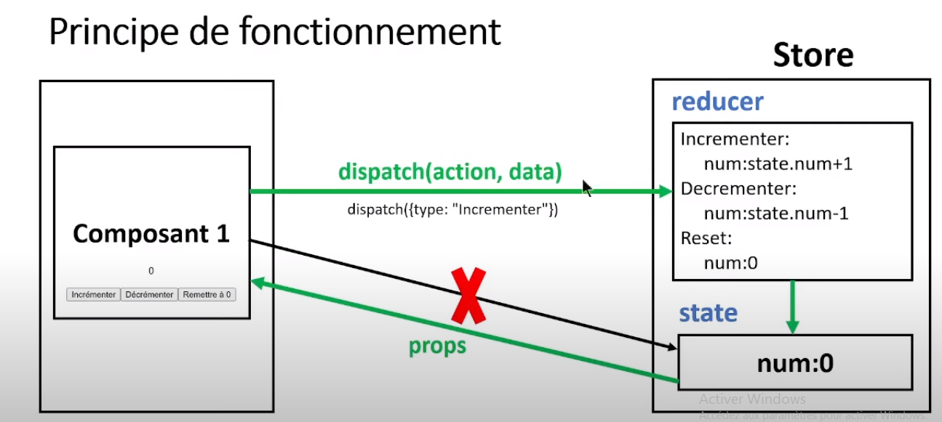

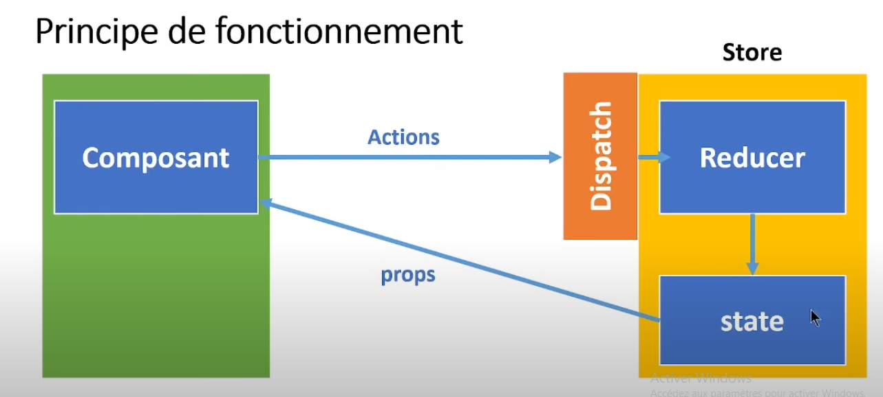



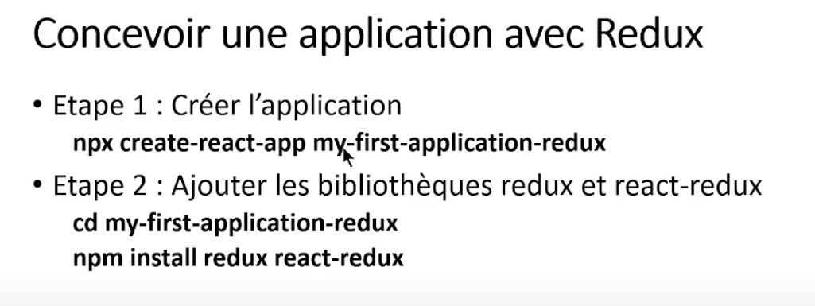

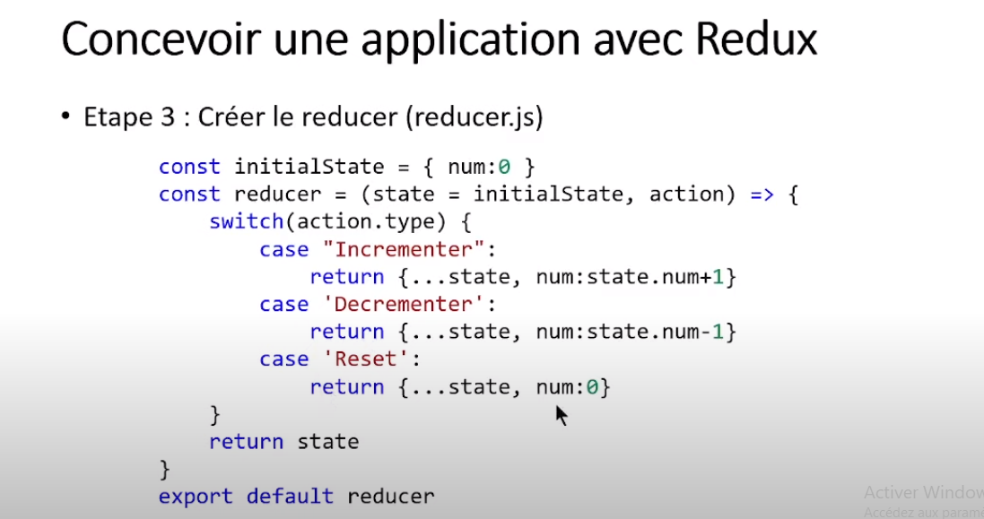

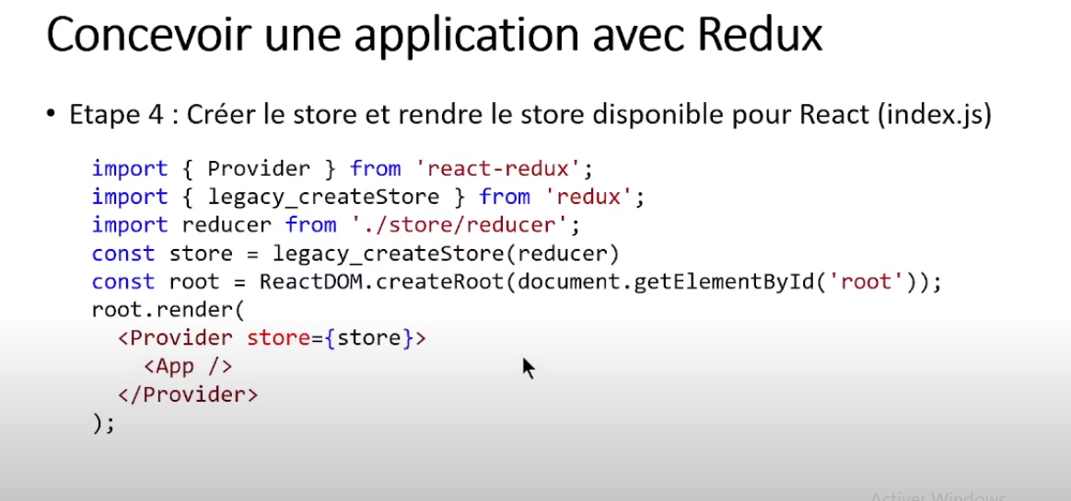

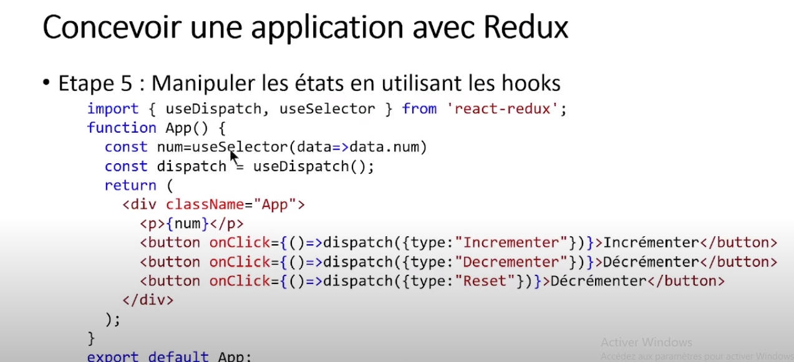

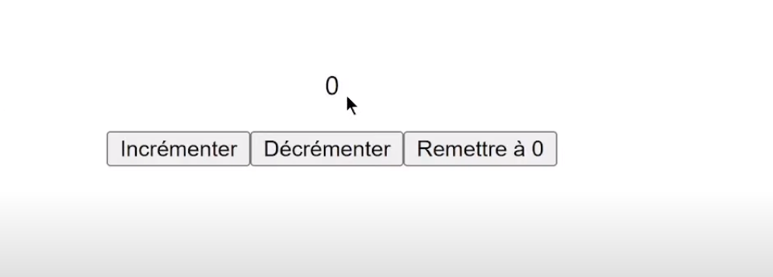

Exemple complet :

App.js

import { connect, useDispatch, useSelector } from "react-redux";

function App(props) {

const num=useSelector(data=>data.cpt);

const dispatch=useDispatch();

 const incrementer=()=>{

    return {type:"INCREMENT"}

 }

  const decrementer=()=>{

     return {type:"DECREMENT"}}

     const reset=()=>{

        return {type:"RESET"}}

    return (

        <div>

                        <div>{num}</div>

        <div className="App">

        <button onClick={()=>dispatch(incrementer())}>+</button>

<button onClick={()=>dispatch(decrementer())}>-</button>

<button onClick={()=>dispatch(reset())}>a zéro </button>

        </div>

        </div>

     );

}

export default App;

index.js

import React from 'react';

import ReactDOM from 'react-dom/client';

import './index.css';

import App from './App';

import { legacy_createStore } from 'redux';

import { Provider } from "react-redux"

import reducer from './reducer';

const store = legacy_createStore(reducer)

const root = ReactDOM.createRoot(document.getElementById('root'));

root.render(

     <Provider store = {store}>

               <App/>

     </Provider>

)

// If you want to start measuring performance in your app, pass a function

// to log results (for example: reportWebVitals(console.log))

// or send to an analytics endpoint. Learn more: https://bit.ly/CRA-vitals

Reducer.js

import { createStore } from 'redux';

const initState = { cpt :0}

const reducer = (state=initState, action)=>{

        console.log("************ ",action.type);

        switch (action.type){

        case 'INCREMENT':return { cpt : state.cpt+1 }

        case 'DECREMENT':return { cpt : state.cpt-1 }

        case 'RESET' : return {cpt :0}

        default :  return state;

        }

}

export default reducer;